In order to convince the educated classes within Iran to give up their nuclear program, many of the propaganda techniques must be employed in unison. We need to bombard every aspect of the Educated Iranians’ lives. We intend to employ social media along with other traditional types of propaganda. Alongside this we should still campaign with traditional media.

“Nuclear weapons can cost over one billion dollars. Within their current state, Iran has many economical quandaries in which should be their point of convergence. For the most part, Iran’s reasoning for nuking Israel is unnecessary and simply a way to show their masculinity. Iran’s economic issues are partly due to the current fallout of the 1979 baby-boom, ergo they are in no condition to produce and employ nuclear warheads.”

This paragraph is an example of a traditional media campaign we should take, since our target audience is made up of educated people, we shouldn’t try to deride them, rather giving them the risks associated with building a nuclear weapon. One thing that should be avoided is vilifying Israel. The people of Iran already are on bad terms with the Israelites, we should not provide the spark that blows up the Middle East.

We intend to use Twitter and Facebook to pass information to the masses about how peace would improve their lives. Along with that, we will make “fake links” to include video that the masses can connect to enforce our message. Our intention is to have uprisings similar to the Arab spring. These links will be sent all over the Arab world to help induce pressure on Iran to abolish their program. Also, we would make our “own” YouTube videos showing student protests of the Nuclear program in Iran and artificially inflate the ‘hits’ to make it seem viral.

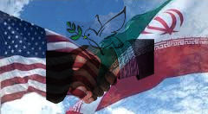The posters play a very important role in the process of convincing the Iranians to not invest their time, money, and effort. Our posters will be uploaded on Facebook and Twitter, so that our nonviolent message, spreading a campaign of peace in the Middle East. Poster one uses the propaganda techniques of plain folks in the form of a handshake in the middle. The second poster uses the technique of transfer in the sense that it symbolizes peace providing an alternative to nuclear war.

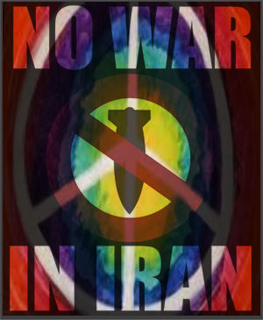

**Leaders of Iran, give up your nukes**

**And we will help you join the modern world.**

Poster 2

Poster One

**Translated into FARSI**

In summary, this is an attack on different aspects of their lives using various forms of media. It has sworked in the past and we feel that this will be just as successful.